**COURSE NO: CSE 3104**

**COURSE TITLE: Peripheral Laboratory**

**PROJECT NAME: Biometric Attendance System**

**DATE: 30 June 2018**

**SUBMITTED TO:**

**Saifuddin Mahmud**

**Assistant Professor,Dept. Of CSE,KUET.**

**MD. Milon Islam**

**Lecturer , Dept. Of CSE,KUET.**

**SUBMITTED BY:**

**Salah-Uddin Ahmed(1507021), Hannan Sagar(1507021), Mushfiqur Rahman(1507028), Sadia Mubasshira(1507030)**

**DEPT. OF CSE, KUET**

**Overview:**

Biometric Attendance System is an Rasp Berry pi based project which is purposed to used in the class room. It is a embedded peripheral system which is designed to take the attendance of the students without calling the attendance rather using the fingerprint id of the students.Mainly the project is used with a fingerprint sensor, and a web server installed on the rasp berry pi.So that it may accept the IOT like view.

**Theory:**

Fingerprint integrable with rasp berry pi has 1000 indexes. So it has capability to store fingerprint id and the pi can use it to match and go with the inputted fingerprint.Rasp berry pi GPIO pins are 3.3v output pin but the fingerprint is 5v operated. So a ttl 3.3v-5v is used to make it work.The python code runs the fingerprint and the circuit stated on the bread board.To view the attendance system there is a web server with MySQL installed on the pi. The php code written on the pi run this part.

**Description:**

There are some components that were used in the project.Here are the list:

1. Rasp Berry Pi
2. Fingerprint sensor
3. TTL-USB to serial converter
4. Push button
5. LED(4 colors)
6. Connecting wire
7. Bread board

4 LEDs and the push button are used with the rasp berry pi GPIO pin.The push button is used to start a class.The white led is used to mean that the program is on the go. The blue led means that the fingerprint is ready to take id. Now if id matches the green led blinks and if id doesn’t matches the red led blinks. If the push button is pressed again the class ends. The attendance can be shown by connecting to the pi’s ip and browsing the attendance.php file.’P’ means present and ‘X’ means absent.1 means class no 1.

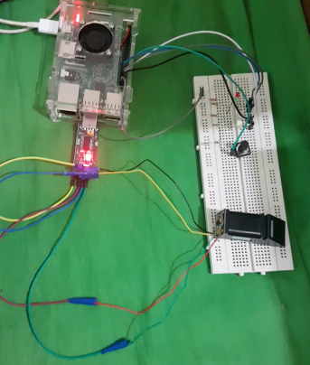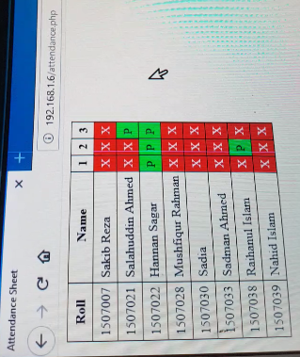

**Figure:** Circuit Diagram an Attendance web view

**Conclusion:**

The project was successful for its purpose.I wish to make it more effective by making it more integrable and more flexible by adding some extra codes in the pi.The classes will be divided for a department by using the total 1000 indexes of the fingerprint sensor.However the peripheral laboratory was very helpful to make this project successful.